## Physical habitats

The physical and chemical environments of the Southern Ocean, combined, form the “physical habitat” that may affect organisms in a number of ways, depending on the suitability of the conditions:

a medium/substratum in/on which to live,

availability of nutrients and other resources (food, light),

a vector for movement, and

exposure to predation or other sources of mortality.

The aim here is to summarise the nature of habitats in the Southern Ocean and how they may vary in space and time. Habitat metrics reported here are those that are considered to represent spatio-temporal scales of primary importance to biota in the Southern Ocean. Some metrics are comparatively unchanging, e.g. bathymetry, while others will need to be reported seasonally. In space, finer grain reporting occurs when taxa are restricted in their distributions, while coarser grain reporting, e.g. whole sectors, is suitable for widely distributed taxa.

Where possible, consideration will be given to changes that have occurred since the industrial revolution. As per the IPCC, we use 1750 as marking the beginning of the industrial period.

### General description of Southern Ocean habitats

Four sectors, each divided into two zones - subantarctic and polar (see map): Map of key features. [Define the boundaries of the zones in each sector.]

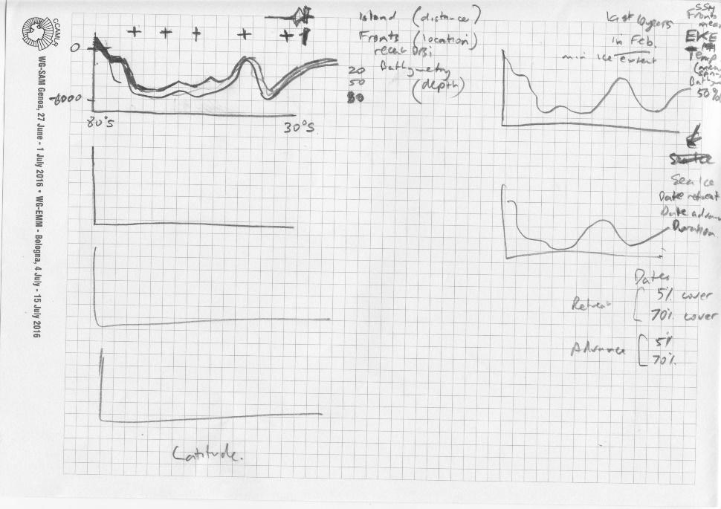

Figures: average section (x-axis is latitude) for a set of attributes in each sector, one panel per sector in a column of 4 panels [method note: if the routines can be developed to account for any polygon and interacting with any land/ice shelf].

|  |  |  |  |
| --- | --- | --- | --- |
| **Col** | **Metric** | **Percentiles** | **Notes** |
| 1 | Depth  Fronts (latitude)  Island (distance > 0m)  Cont.Shelf >-2000m (distance >0m)  Plateau/bank >-2000m (dist.>0m)  Ice shelf (distance >0m)  Total distance across sector | 20,50,80  20,50,80  Sum distance  Sum distance  Sum distance  Sum distance  Total | Vertical (bold within grey shade)  Horizontal (Point 50 with bar 20-80)  Vertical bar  Vertical bar  Vertical bar  Vertical bar  Vertical bar |
| 2 | Depth  Fronts  Med last 10 yrs of med Feb:  SSH  EKE  Temperature  Westerly wind strength (+/-) | 50  50  20,50,80  20,50,80  20,50,80 | Point  Point  Vertical (bold within grey shade)  Vertical (bold within grey shade)  Vertical (bold within grey shade) |
| 3 | Depth  Fronts  Zonal-Sum, stats over last 10 yrs:  Average Chl Oct-Dec  Average Chl Jan-Mar | 50  50  20,50,80  20,50,80 | Point  Point  Vertical (bold within grey shade)  Vertical (bold within grey shade) |
| 4 | Depth  Fronts  Zonal-median sea ice 95% conc, stats over last 10 yrs:  Julian day advance  Julian day retreat  Days duration | 50  50  20,50,80  20,50,80  20,50,80 | Point  Point  Vertical (bold within grey shade)  Vertical (bold within grey shade)  Vertical (bold within grey shade) |
| 5 | Depth  Fronts  Zonal-median sea ice 70% conc, stats over last 10 yrs:  Julian day advance  Julian day retreat  Days duration | 50  50  20,50,80  20,50,80  20,50,80 | Point  Point  Vertical (bold within grey shade)  Vertical (bold within grey shade)  Vertical (bold within grey shade) |